**Sprites to denote optimal time to pull through rope being slack/taught**

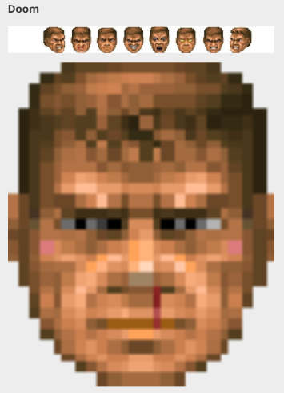

http://www.gamesradar.com/the-10-most-creative-life-bars/ [2013]



No tension

Full tension

**Colour background change**

<http://codezag.com/wp-content/uploads/2015/03/change-background-color-javascript.gif>

Maintain coloured perimeter in current version to indicate current player turn.

Remainder of background gradient change/pulse with colour.

Closer to colour (e.g. green) better pull.

Closer to colour (e.g. red) worse pull.

Could be made to fit a rhythm, rather than set gradient change/pulse change.

**Extra input**

Sprites with theme relevant alternative to ‘Heave-ho’ could pop in/out at optimal time.

Haptic feedback could pulse to indicate optimal time.

Sound to indicate time.

These methods would enable a clear, NON-patronising time limit to be placed on player turn if needed. (assuming vertical oriented game scene, no problem RE passing device between players).